3.2 Project: Abstraction, Constructors, & Access Specifiers

Jessie Marie Sosniak

ECPI University

SDC330L: Object Oriented Programming using Java Lab

Mr. Randy Bellet

November 25, 2025

This program is a menu driven contacts application that demonstrates inheritance, interfaces, abstract classes, constructors, access specifiers, composition, and polymorphism in Java. When the application starts, the user is greeted with a title line and clear instructions on how to interact with the system. The main menu provides options to add, remove, update, or display contacts, with X reserved for exiting the program. Input is not case sensitive, so both uppercase and lowercase letters are accepted. Exiting requires confirmation to prevent accidental termination, which ensures the user experience is straightforward while also showing control flow and input validation.
The program begins with the Contact interface, which defines the contract that all contact types must follow. It includes getters for shared fields such as name, phone, email, and address, along with the abstract displayContact method. The AbstractContact class implements this interface and provides the shared fields, constructor, and getter methods. By centralizing these common elements, AbstractContact reduces redundancy and enforces consistency across all contact types.
From AbstractContact, the hierarchy splits into two paths. BusinessContact extends AbstractContact directly, adding fields for company name, fax, and a work related flag. This class overrides displayContact to show both the shared and business specific details. On the other side, PersonalContact is an abstract subclass of AbstractContact that introduces birthday and nickname fields. It leaves displayContact abstract so that its subclasses can specialize. FamilyContact and OtherContact extend PersonalContact, fixing the relation as Family or Other and implementing their own display logic. This layered design demonstrates inheritance, constructor chaining, and polymorphism in action.
The AddressBook class uses composition to manage a collection of contacts. It stores them in an ArrayList and provides methods to add and display contacts. Because it works with the Contact interface, AddressBook can handle any subclass polymorphically, whether Business, Family, or Other. Finally, the App class ties everything together with a menu driven interface. It uses Scanner for input, creates the appropriate contact objects based on user choices, and interacts with AddressBook to store and display them. Together, these classes illustrate the core object oriented principles required in Weeks 1 through 3: inheritance, interfaces, abstract classes, constructors, access specifiers, composition, and polymorphism.
Unfortunately, I had to rework my program from the ground up to make a more intuitive class structure to allow for the new concepts introduced throughout this course. Moving forward, this program should be modular so any changes made are expansive, rather than starting from scratch again. Because of these changes, my project has diverted from the outline I provided in Week 2… but I think it was a change for the better. As of right now, Update and Delete operations have yet to be implemented for next week. Please let me know what you think!
GITHUB LINK: https://github.com/Ecoz03/SDC330L-Advanced-Object-Oriented-Programming-Using-Java-Lab/releases/tag/Phase-3
Screenshots below.
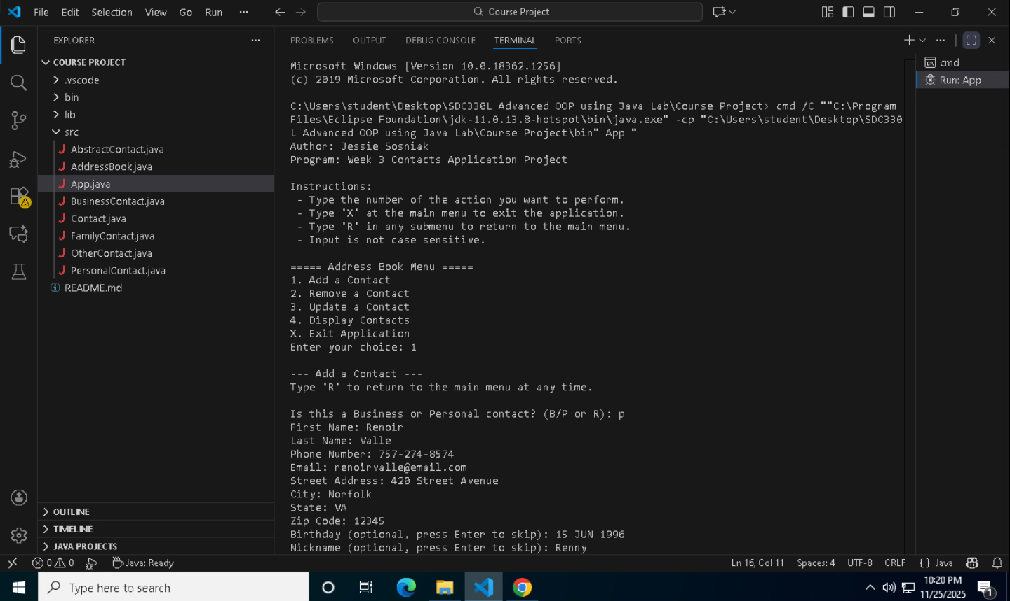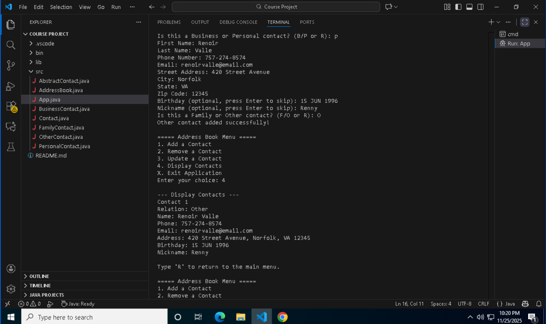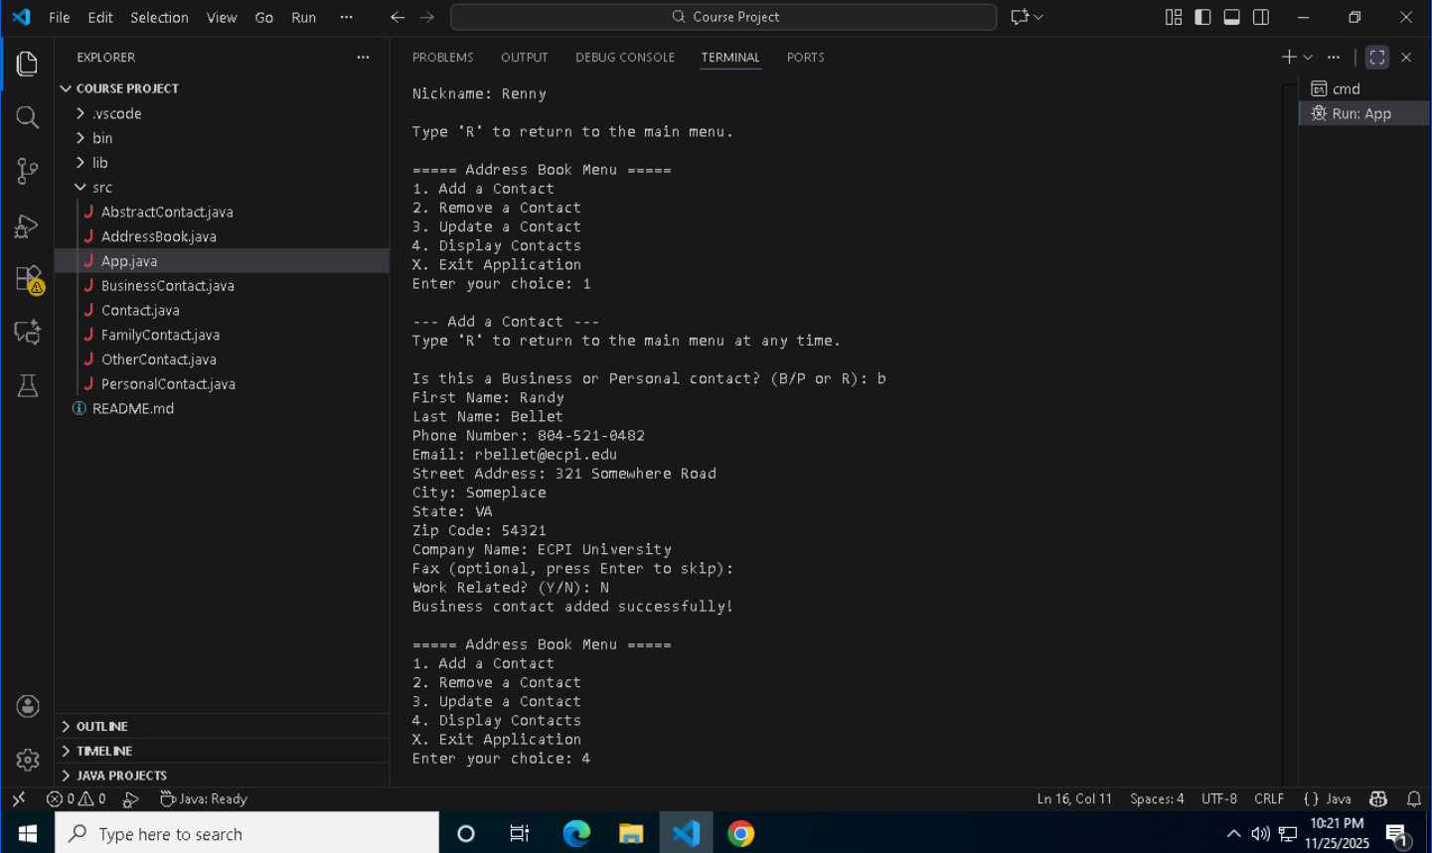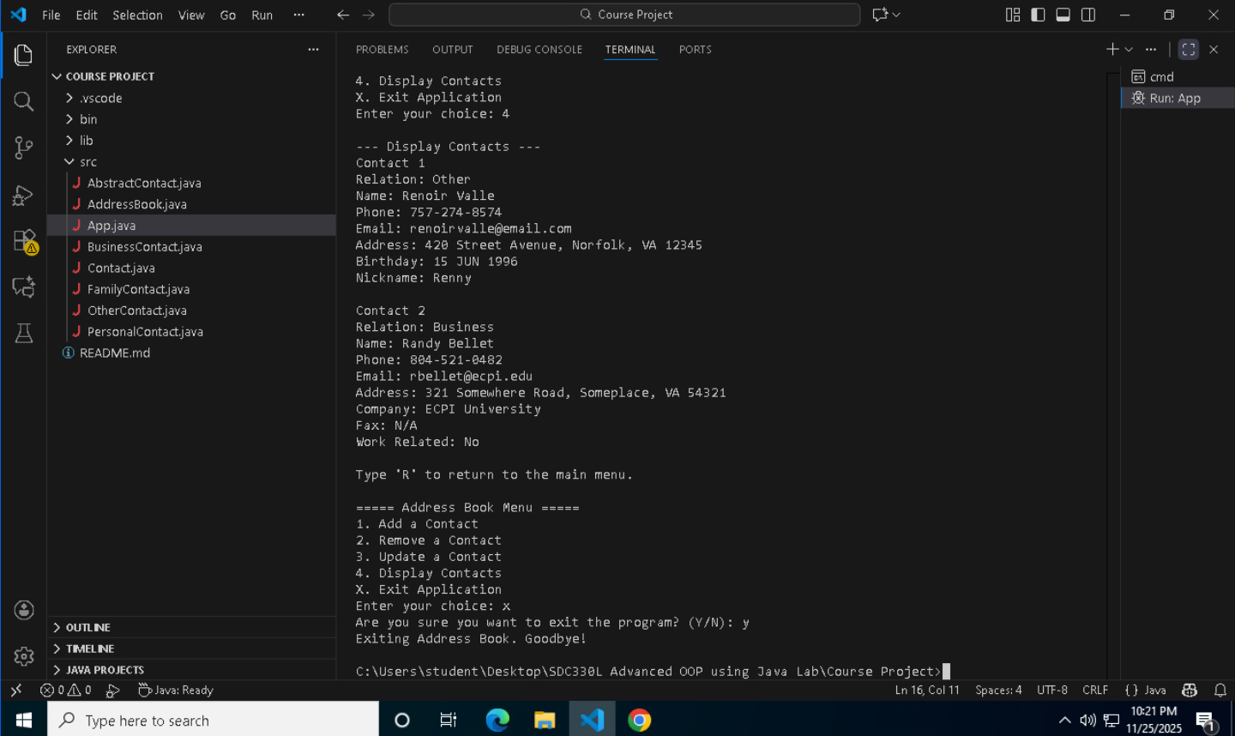
Resources

